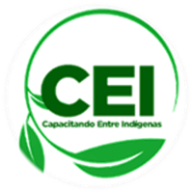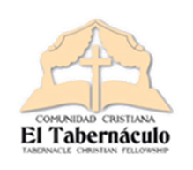

*March 2023*

Philippians 3:13-14

Brethren, I myself do not pretend to have already attained it; But one thing I do: forgetting certainly what is left behind, and extending myself to what is ahead, I continue to the goal, to the prize of God's supreme calling in Christ Jesus.

Letter Noticias Porras Family  **Manuel, Andy Manuel, Yorleny, and Andy**

***Ujarrás indigenous people***

Image containing person, interior, board, food

Automatically generated description

Greetings to friends of the family and the CEI project!

God is working in the indigenous communities and we want to share with you some of what He is doing.

***When you want you can***

Doña Dinora, 68 years old, did not have the privilege of attending school. She tells us that the way she learned to read was when she spoke with God and she replied that he would teach her through the Bible. Now she is enrolled and taking both the pastry and theological foundations courses. Heer willingness to learn encourages us.

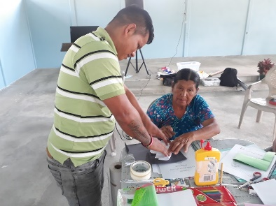

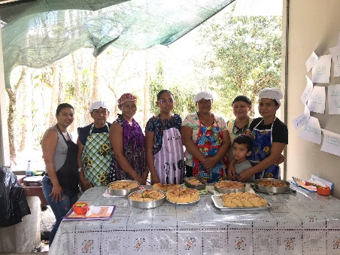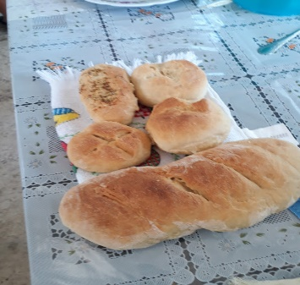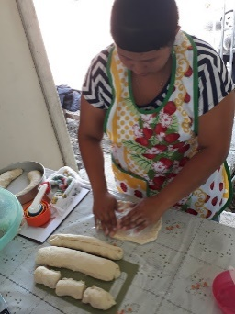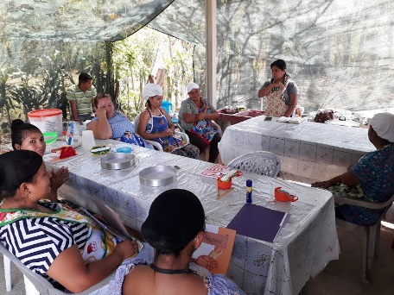

**If you are interested in supporting us, you can:**

In the United States through:

<https://www.partners-in-joy.org>

In Costa Rica

Banco de Costa Rica CR08015202250002506278 SIMPE MOVIL 61 41 86 08 Yorleny Rodriguez

The pastry course has been one of the most requested within the communities, as it facilitates new economic income for families. We started with eight students who surprised us with their willingness from the beginning. With a strong interest in learning, we have already finished the first course and they are putting into practice what they have learned. God is also motivating their hearts during devotional times.