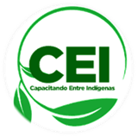

***November 2022***

**Porras Family**

***Manuel, Yorleny, and Andy***

**Isaiah 6:8: Then I heard the voice of the Lord, saying, Whom shall I send, and who shall go for us? Then I answered, "Here I am, send me."**

We are about to finish a year, and in this journey, we have seen God's provision through many people who have lent us a hand, some supporting us with their financial contribution, and some who have sustained us by praying constantly for each course that has been taught.

As a CEI team we have come together with one faith and hope in God's wonderful work in the hearts of each of the students. We give glory to the Lord for His faithfulness!



**Pastry courses**

It is wonderful to see how God is working in the lives of the pastry students. We are almost finished with the 6 training blocks, and we can see the difference in their faces—more confidence, and above all they are recognizing the Lord in their lives.

**Youth Leadership Course**

This month we had the opportunity to share a good time again with the youth leaders, with many laughs and valuable learning times.

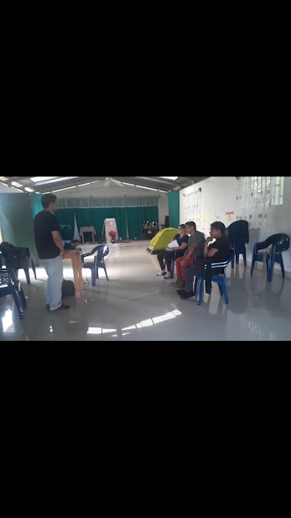

They shared with us how their first meeting went with the young people of their congregation. It went well and they are eager to continue. We also had the first workshop on youth counseling, leaving them anxious to learn more about that topic.

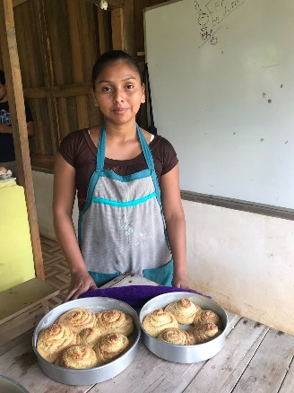

**Sunday School Teachers Course**

Every month at the beginning of the course, the students are introduced to a new topic. This time we shared about counseling for children. The topic aroused an interest that sparked a lot of conversation about personal experiences. The steps to develop counseling became very clear. We need to resume working with children and together with the church to help families.

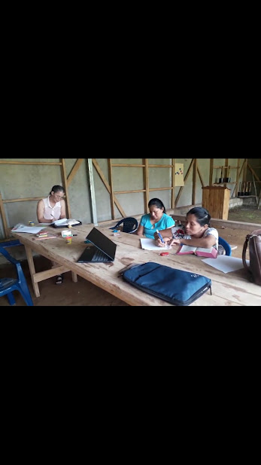

**Counseling Course**

Out of 100,000 inhabitants, there is an average of 13.92% probability of suicide in indigenous territories according to UNICEF. In our experience we have seen 6 people in a single month commit suicide in indigenous territory.

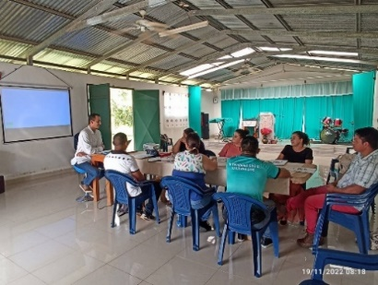

**If you are interested in supporting us, you can:**

**In the United States through: https://www.partners-in-joy.org/**

**In Costa Rica**

**Banco de Costa Rica CR08015202250002506278**



As a result of our experience and seeing the data of UNICEF and other institutions, we felt the need to teach a course in biblical counseling to provide tools that can address this issue so that the church can have a part since it is of vital importance for the communities. Our desire is to form a team of professional counselors to provide workshops; we are praying that God will send workers.